THE APPROACH

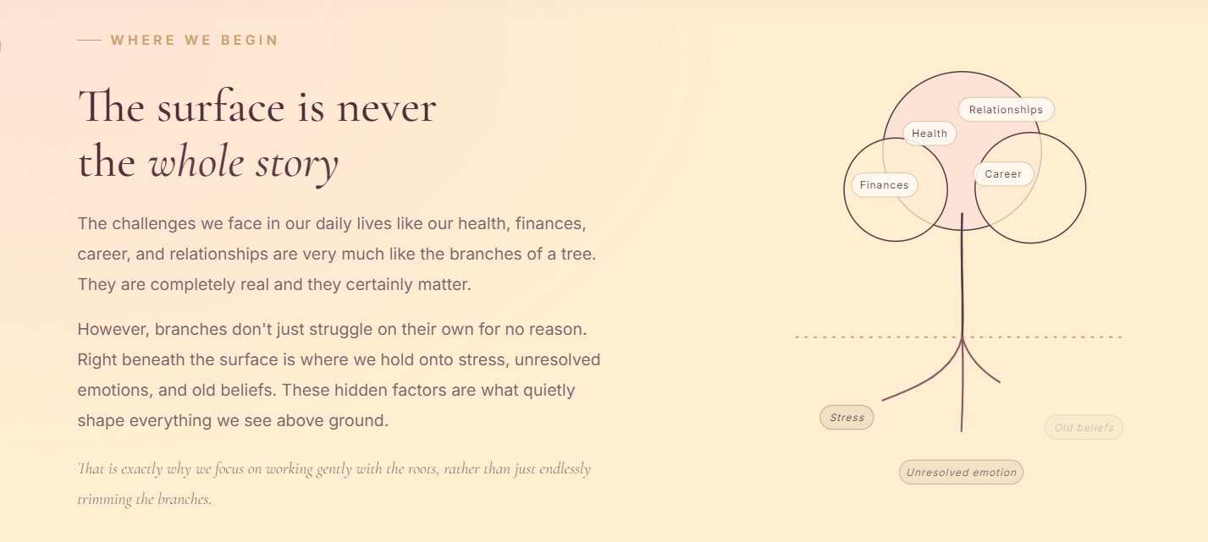

This is really beautiful
THIS IS EXACTLY WHY I CHOSE THE TREE OF LIFE
Roots are the hidden beliefs and hurts that form the tree and shape your life
The health, career, business, and relationship struggles are the branches and leaves –
And only when you heal at the deepest level do you heal,
So I had the butterfly breaking the boundaries
It denotes transformation and freedom

CAN WE HAVE MY LOGO TREE HERE?

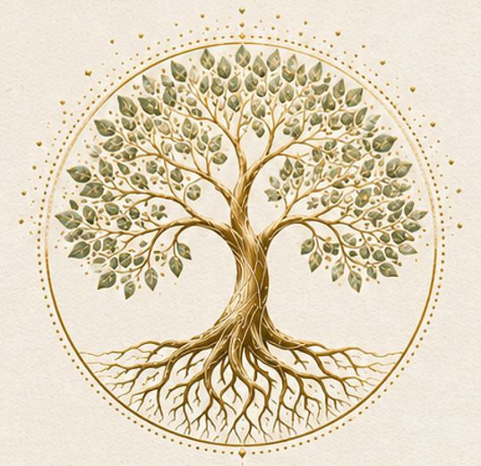



WILL GIVE YOU A HIGH RES LOGO

ABOUT PAGE

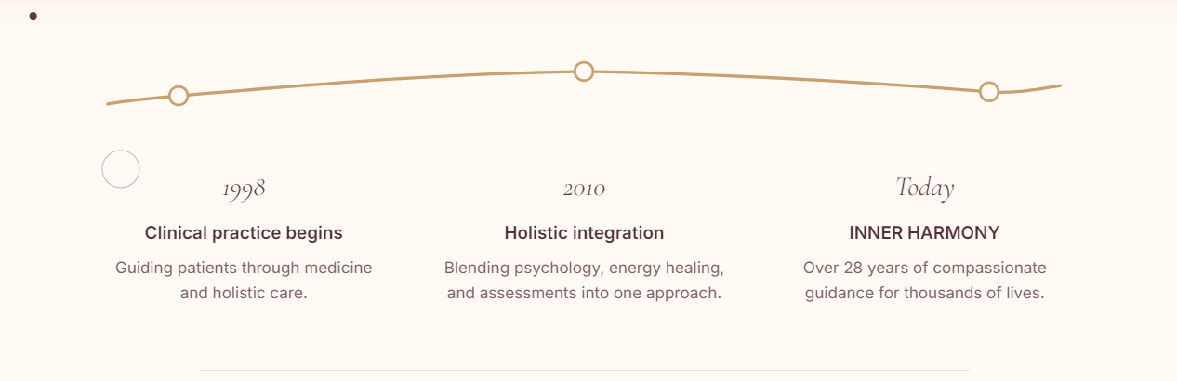
No need for this

25 years and 2000+

REIKI GRANDMASTER MUST BE WRITTEN

Hello, I'm Dr. Gargee Gadgil, founder of INNER HARMONY - Heal Within. Shine Beyond
A physician, a holistic healer, a wife, and a mother of two children.

I don't believe people need fixing. I believe they need a deeper understanding.

For over 28 years of my clinical practice, I have had the privilege of guiding thousands of individuals, parents, children, and families on their journey towards health, greater self-understanding, emotional well-being, holistic parenting approaches, financial abundance, good career choices, and personal growth.

My goal has always been - To create a compassionate, non-judgmental space where people feel seen, understood, and empowered to transform their lives.

I believe every person already carries the answers they seek. Sometimes, we simply need the right guidance to uncover them.

My greatest joy is witnessing people reconnect with their inner strength, embrace their authentic selves, and step into a life filled with greater purpose, confidence, and harmony.

TAROT PAGE
CHANGE THE COLOR TO LIGHTER SHADES please
it is too gaudy
USE THE TAROT CARD WHICH HAS PINK
FIRST CARD IS TOO GAUDY, I WILL GIVE YOU ONE
THE CARDS DON’T FLIP WELL
THE WRITE UP SHOULD BE IN A BOX BELOW THE CARD SO THAT THE CARD IS BEAUTIFULLY VISIBLE AND THE WRITE UP IS VISIBLE AND DOES NOT MOVE

CAREER
I DON’T LIKE BLUE COLOR
Please can you change it

TEST – written in tally
Want to integrate it
IMAGES + RESULT INTEGRATION

EMPOWERED PARENT BLUEPRINT

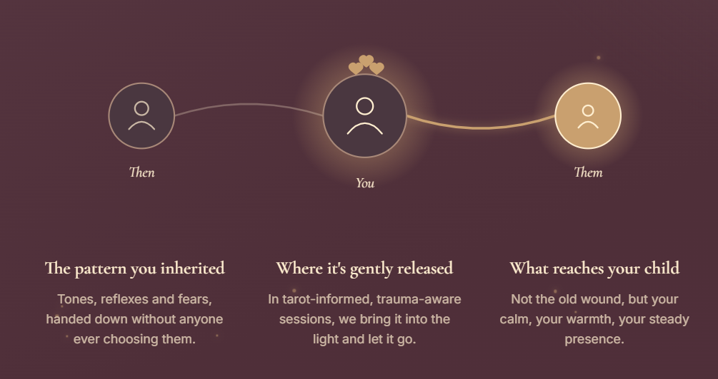

The THEN, YOU, THEM SHOULD BE BIG, IT IS NOT VERY READABLE

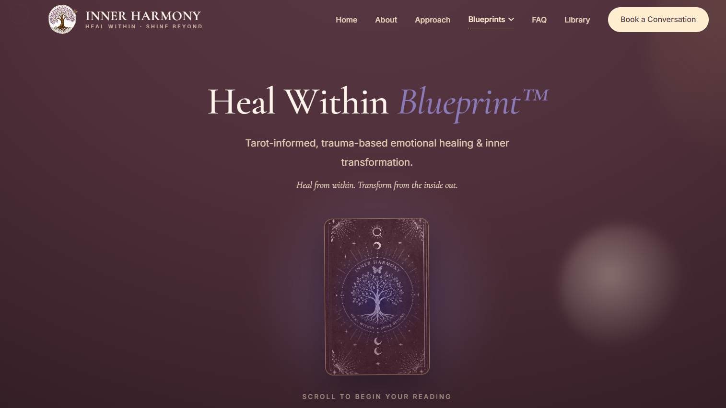
- BACKGROUND IS TOO DARK – PLEASE MAKE IT LIGHT LIKE THE OTHER PAGES
- TAROT CARD NEEDS TO BE CHANGED – WILL GIVE YOU ONE -
- BACK OF THE TAROT CARD – COLORS MENTIONED DOWN

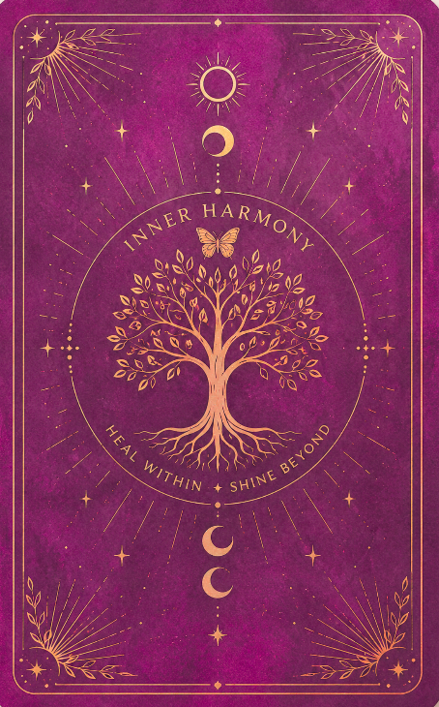
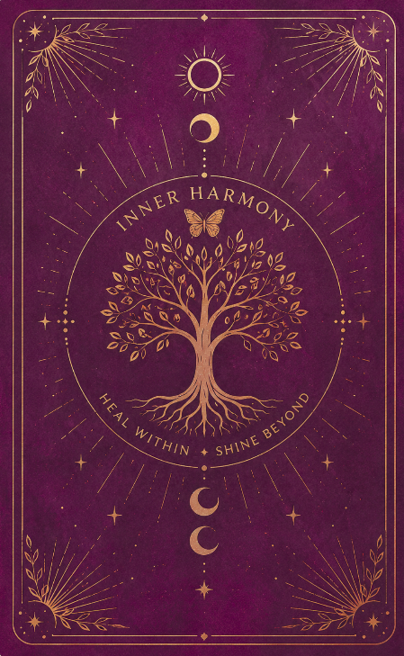

Magenta #902769 Dark magenta - #5d1140
I WOULD PREFER MAGENTA RATHER THAN
THIS DARK MAGENTA

THE TAROT CARDS DON’T FLIP WELL – THE FOOL, MAGICIAN ETC.

CAN WE HAVE THE CARD DIRECTLY FACING US, AND JUST A BUTTON/MSG AT THE BOTTOM – “FLIP” or something and when it flips, the prompts are displayed at the back ((instead of having the tarot card back facing us, and flipping it to reveal the card and the msg)) ((in case you don’t understand I can explain it))

THIS CARD IS THE MAIN TAROT FLIP CARD YOU ARE USING AT THE START OF THE TAROT WEB PAGE
((CURRENTLY IT HAS A BLUE LADY))



PLEASE USE THE CARDS I AM SHARING THE ORIGINALS ON THE DRIVE
- THE EMPRESS
- THE FOOL
- THE MAGICIAN

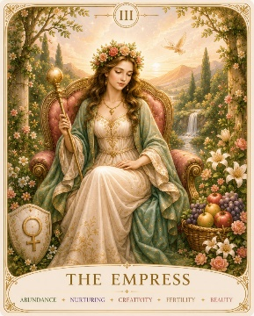

Approach
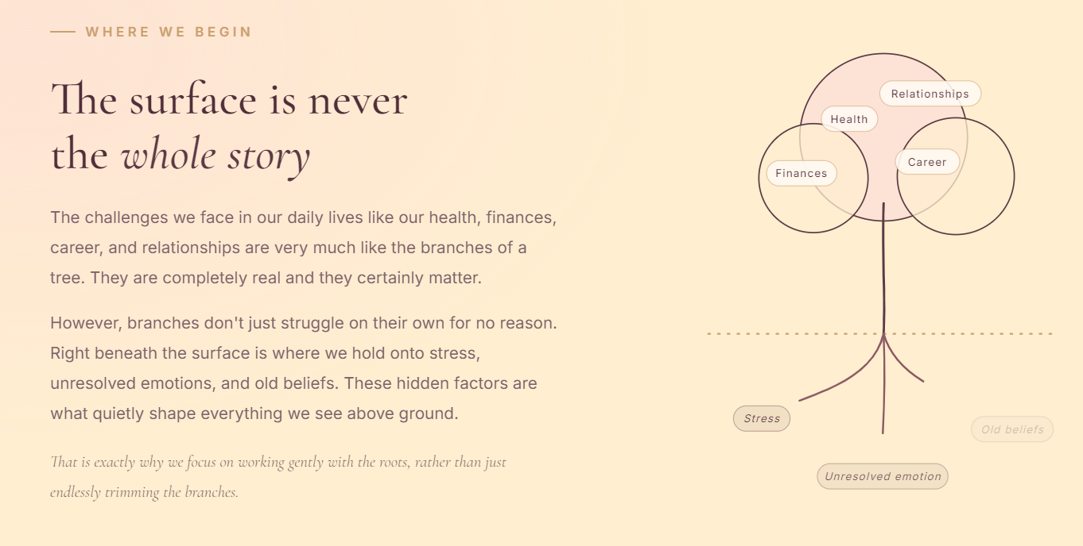

THIS IS THE EXACT PHILOSOPHY OF INNER HARMONY AND THE LOGO
If we can show leaves, trunk, roots and the butterfly finally breaking the barrier and flying away
(instead of the circles and lines)



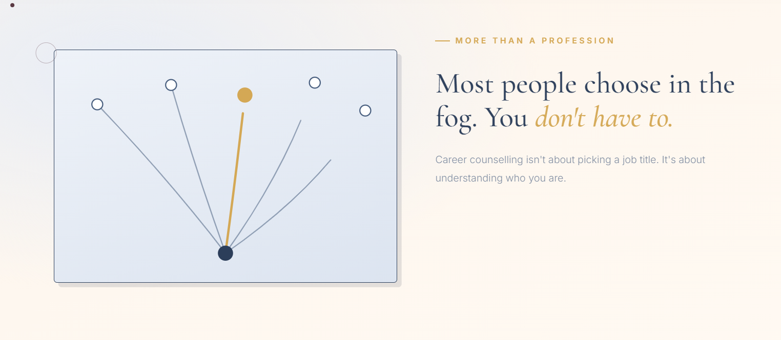

DON’T LIKE BLUES!!!
CAN WE CHANGE THIS COLOR?

CERTIFIED TAROT-BASED TRAUMA-INFORMED COACH & HEALER

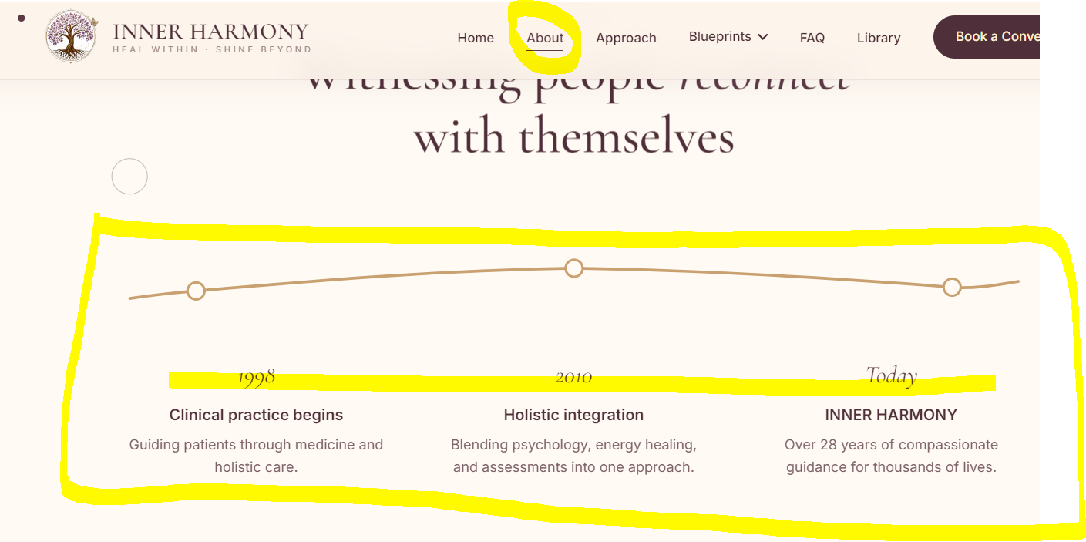

This is not required.
I think I had mentioned it earlier too.
CAN WE REMOVE IT?

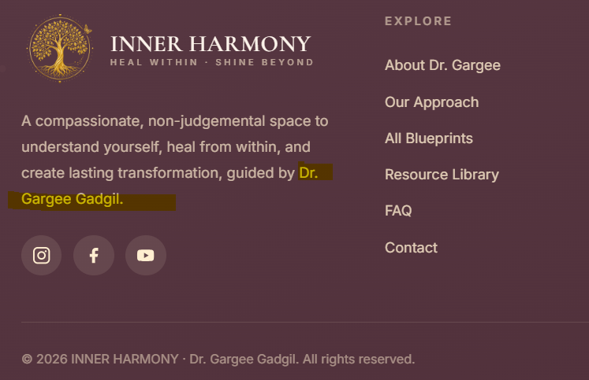

I don’t know if it is under formatting right now; if not, the name (Dr. Gargee Gadgil) should come down on the next line

UNDER HEAL WITHIN (TAROT PAGE)

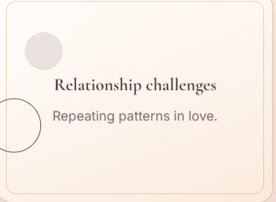
Instead of “Repeating patterns in love” Please could you change to “Patterns that keep you stuck”

SAME PAGE
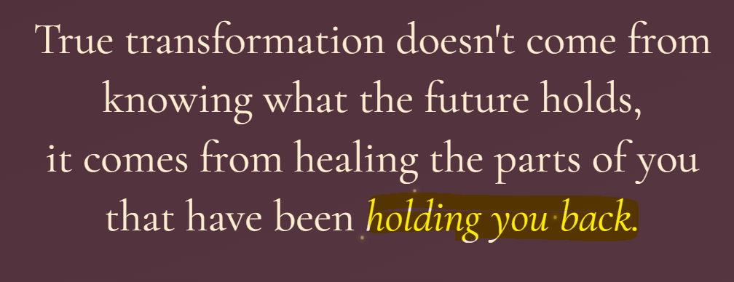
CAN THIS BE GOLDEN / YELLOW – like you have done for a few other headers

The WHATSAPP CHAT & REACH OUT TO Dr. GARGEE BOTH HAVE TO BE CONNECTED TO THE OTHER NUMBER
– (+91) 91521 55022
(((NOT MY REGULAR NUMBER 9930034340)))

TALLY INFORMATION
https://tally.so/help/google-sheets-integration
login: Gargee.gadgil@gmail.com
PWD: MNn49Ww7#e!SRUd

UPLOADED ON DRIVE:
- TAROT CARDS – 3 + 1
- PHOTO – mine
- Archetype images

